**Angular Web Development – Assignment No 8**

**Q. No. 1.:**

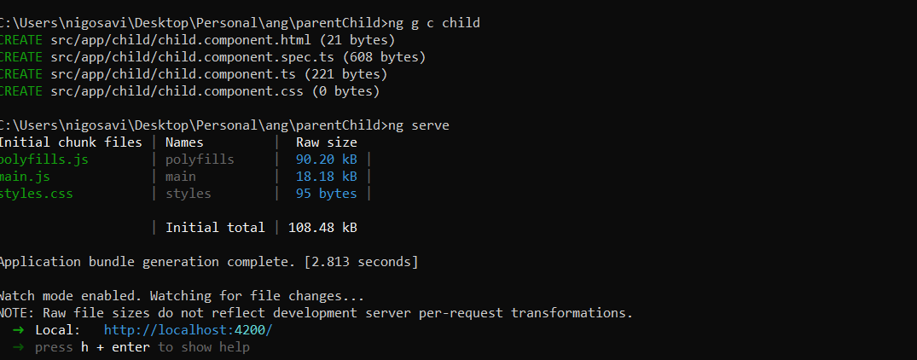

**Q.No. 3.:-**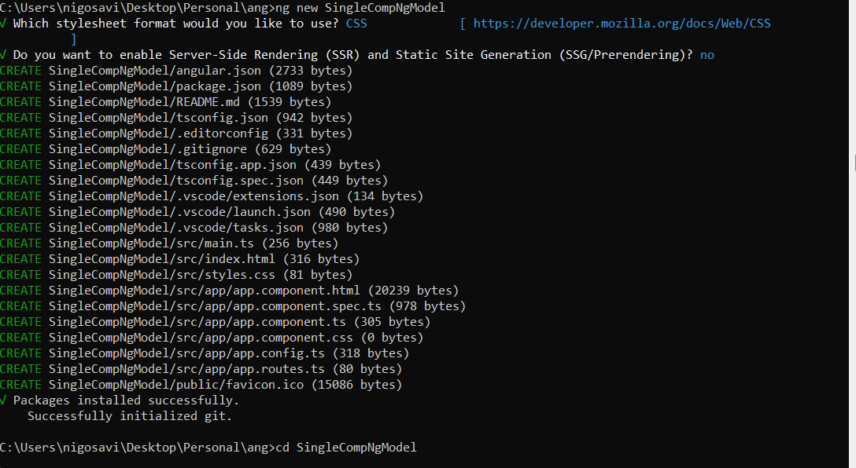

**Q. No. 4:-**

